Christmas Eve Service
Laurinburg Presbyterian Church

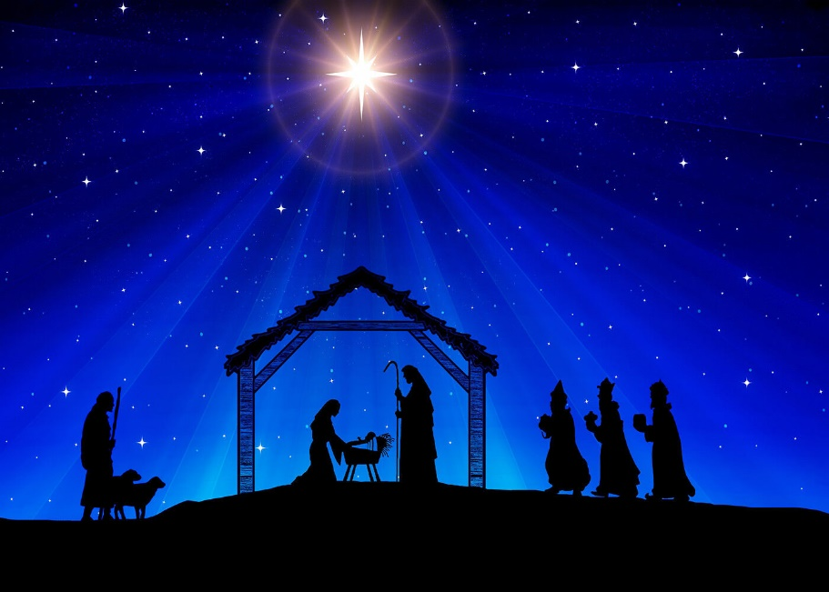

Rev. Rebekah Carpenter, Senior Pastor
Holly Albrecht, Director of Christian Education
Dr. José Rivera, Director of Music
Lee Harris, Organist

December 24, 2025 5:30 pm

Welcome Rev. Rebekah Carpenter
“Happy Birthday, Jesus”
Prelude “Greensleeves” by Richard Purvis
Lighting of the Christ Candle The McQueen Family
Leader: We light this candle as a sign of the coming light of Christ.
In the Wilderness prepare the way of the Lord!
People: Make a highway in the desert for our God.
Leader: From ages of old, no ear has heard, no eye has seen one so glorious as the Lord our God, for whom we wait. Every valley shall be lifted, every mountain and hill made low; then the glory of the Lord shall be revealed.
God’s anointed one is coming – to bring good news to the oppressed, to bind up the brokenhearted, to proclaim liberty to the captives, and to announce the time of the Lord’s favor. The promise of the Lord is sure; the realm of God will be established forever.
Now a child has been born for us, a son given to us; authority rests upon his shoulders, and he is called Wonderful, Counselor, Mighty God, Everlasting Father, Prince of Peace.
The people who walked in darkness have seen a great light;
People: those who lived in a land of deep darkness, on them light has shined.
Leader: Tonight, we light this candle as we celebrate the birth of Christ. The candles of hope, peace, love and joy all remind us that Christ is our light and the source of eternal hope, everlasting peace, boundless love, and endless joy.
Candle Lighting
Leader: Please join together in singing the first verse of hymn #85,
“Light One Candle to Watch for Messiah”
Candle Lighting Hymn #85 “Light One Candle to Watch for Messiah” (1st verse)
*Call to Worship Cooper Sutherland
Leader: In this silent night,
All We ponder your mystery with Mary and Joseph.
Leader: On this holy night,
All: We come with the shepherds to worship.
Leader: On this night of joy for the world,
All We sing praises with choirs of angels.
Leader: In the darkness of this night,
All: We celebrate the Light of the World.
*Invocation Claire Carmichael
Let us pray. Dear God, there are so many things we do not know or understand. Your ways are higher than our ways and your thoughts higher than our thoughts. As we lean into the mystery and miracle of the Christ Child, may we lean into You - the One who knows all. In Jesus’ mighty name we pray. Amen.
Call to Confession Summer Bartholomew
The grace of God has appeared, bringing salvation to all and teaching us to renounce what is evil in this world. Like a great light in a land of deep darkness, the mercy of the Lord shines on us. Christ Jesus came to save us, not because of our works, but according to the mercy of God through the water of rebirth and the renewal of the Holy Spirit.
Trusting in Gods Grace, let us confess our sin:
Prayer of Confession
God of grace and mercy, you give us the greatest gift of all, your Son Jesus, but we confess we get caught up in our own gift giving on this holy night. You offer us new life in the babe of Bethlehem, but we smile at the baby and forget the new direction he offers. Jesus was born in human flesh, but we fail to see the dignity in the human lives around us. Forgive us, O God, and help us cherish the meaning in your gifts of wonder in the Christ Child.

Assurance of Pardon Sarah Beth McLaurin
God has poured out the Holy Spirit upon us through Jesus Christ our Savior, so that, having been justified by his grace, we might have the hope of eternal life.
Time With Children Dr. Hillary Sessions
Christmas Eve Offering
*Hymn # 119 “Hark! The Herald Angels Sing”
Scripture Psalm 146:6-10 Jackson Sellers
⁶ He is the Maker of heaven and earth,
the sea, and everything in them—
he remains faithful forever.
⁷ He upholds the cause of the oppressed
and gives food to the hungry.
The Lord sets prisoners free,
⁸ the Lord gives sight to the blind,
the Lord lifts up those who are bowed down,
the Lord loves the righteous.
⁹ The Lord watches over the foreigner
and sustains the fatherless and the widow,
but he frustrates the ways of the wicked.
¹⁰ The Lord reigns forever,
your God, O Zion, for all generations.
Praise the Lord.
Scripture Luke 2:1-20 (read during the message) Turner Bounds
2 In those days Caesar Augustus issued a decree that a census should be taken of the entire Roman world. ² (This was the first census that took place while^{[a]} Quirinius was governor of Syria.) ³ And everyone went to their own town to register.
⁴ So Joseph also went up from the town of Nazareth in Galilee to Judea, to Bethlehem the town of David, because he belonged to the house and line of David. ⁵ He went there to register with Mary, who was pledged to be married to him and was expecting a child. ⁶ While they were there, the time came for the baby to be born, ⁷ and she gave birth to her firstborn, a son. She wrapped him in cloths and placed him in a manger, because there was no guest room available for them.
⁸ And there were shepherds living out in the fields nearby, keeping watch over their flocks at night. ⁹ An angel of the Lord appeared to them, and the glory of the Lord shone around them, and they were terrified. ¹⁰ But the angel said to them, “Do not be afraid. I bring you good news that will cause great joy for all the people. ¹¹ Today in the town of David a Savior has been born to you; he is the Messiah, the Lord. ¹² This will be a sign to you: You will find a baby wrapped in cloths and lying in a manger.”
¹³ Suddenly a great company of the heavenly host appeared with the angel, praising God and saying,
¹⁴ “Glory to God in the highest heaven,
and on earth peace to those on whom his favor rests.”
¹⁵ When the angels had left them and gone into heaven, the shepherds said to one another, “Let’s go to Bethlehem and see this thing that has happened, which the Lord has told us about.”
¹⁶ So they hurried off and found Mary and Joseph, and the baby, who was lying in the manger. ¹⁷ When they had seen him, they spread the word concerning what had been told them about this child, ¹⁸ and all who heard it were amazed at what the shepherds said to them. ¹⁹ But Mary treasured up all these things and pondered them in her heart. ²⁰ The shepherds returned, glorifying and praising God for all the things they had heard and seen, which were just as they had been told
The Message Rev. Rebekah Carpenter
“We Do Not Know, Yet We Know”
Special Music “Mary Do You Know?” by Mark Lowry
Susan Williams, solo & Buddy Greene
The Communion
Invitation
The Words of Institution
Prayer After Communion
*Hymn # 122 “Silent Night, Holy Night!”
The words for this carol are printed on the back of the bulletin. Ushers will light candles on the aisles. Please pass the light along your row. We will raise our candles during the last verse and extinguish the candles after the postlude as we carry the light into the world."
Charge Rev. Rebekah Carpenter
Benediction Luke 1:46-55 Poppy Bounds
⁴⁶ And Mary said:
“My soul glorifies the Lord
⁴⁷ and my spirit rejoices in God my Savior,
⁴⁸ for he has been mindful
of the humble state of his servant.
From now on all generations will call me blessed,
⁴⁹ for the Mighty One has done great things for me—
holy is his name.
⁵⁰ His mercy extends to those who fear him,
from generation to generation.
⁵¹ He has performed mighty deeds with his arm;
he has scattered those who are proud in their inmost thoughts.
⁵² He has brought down rulers from their thrones
but has lifted up the humble.
⁵³ He has filled the hungry with good things
but has sent the rich away empty.
⁵⁴ He has helped his servant Israel,
remembering to be merciful
⁵⁵ to Abraham and his descendants forever,
just as he promised our ancestors.”
(Why we sit for the Postlude- The Prelude and Postlude begin and conclude our corporate worship. The first allows us to meditate as we transfer from private worship to group worship, while the Postlude gives us the time and opportunity to translate what we have learned and experienced in the church service into our private lives and plans for the week. If you must leave before it ends, please exit reverently.)
Postlude “Silent Night, Holy Night!” arr. by John Williams
*Those who are able are requested to stand

As you leave this holy night, may the light of Christ born at Christmas go with you into the days ahead. May it bless the year unfolding before you—lighting your path, renewing your hope, and stirring your courage to love deeply and live faithfully. Carry this light into a world that longs for peace, kindness, and joy. And as the new year dawns, may you shine with grace, bearing God’s love wherever you go.



Silent Night, Holy Night

Silent night, holy night!
All is calm, all is bright
‘round yon virgin mother and child!
Holy Infant, so tender and mild
Sleep in heavenly peace, Sleep in heavenly peace.

Silent night, holy night!
Shepherds quake at the sight;
Glories stream from heaven afar,
Heavenly hosts sing “Alleluia:
Christ the Savior is born, Christ the savior is born.

Silent night, holy night!
Son of God, love’s pure light
Radiant beams from thy holy face,
With the dawn of redeeming grace,
Jesus, Lord at thy birth, Jesus Lord at thy birth.

Silent night, holy night!
Wondrous star, lend thy light;
With the angels let us sing,
Alleluia to our King:
Christ the Savior is born, Christ the Savior is born.

